Semantic Chunking Pipeline
Purpose:
The purpose of this study is to analyze and improve how documents are segmented before retrieval in modern semantic search and RAG systems. Currently, most systems rely on fixed-size or sliding-window chunking, which often breaks semantic continuity and negatively impacts embedding quality and retrieval accuracy.
This research explores semantic chunking as a meaning-aware alternative, where text is split based on topic shifts rather than arbitrary length. The goal is to evaluate its impact on retrieval performance, compare it with traditional chunking approaches, and establish clear guidelines on when and why semantic chunking should be used to improve relevance, precision, and overall system effectiveness.

Flowchart:
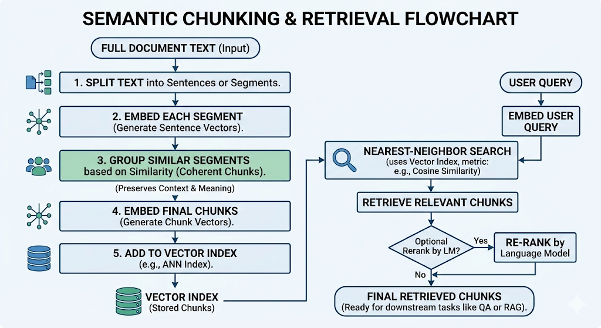
Semantic chunking splits a document into meaningful, contextually coherent pieces for retrieval. In practice, the text is first split into sentences or segments, then each segment is embedded (mapped to a high-dimensional vector). Sentences whose embeddings are very similar are then grouped together into chunks[1][2]. This preserves context and meaning during retrieval[1][2]. After chunking, each chunk is itself embedded and added to a vector index (e.g. an ANN index). At query time, a query is embedded and nearest-neighbor search (using a metric like cosine similarity) retrieves the most relevant chunks, which can then be optionally re-ranked by a language model. (This pipeline corresponds to RAG systems’ document ingestion and semantic search stages[3][1].)

Retrieval Methods: Sparse vs. Dense Search
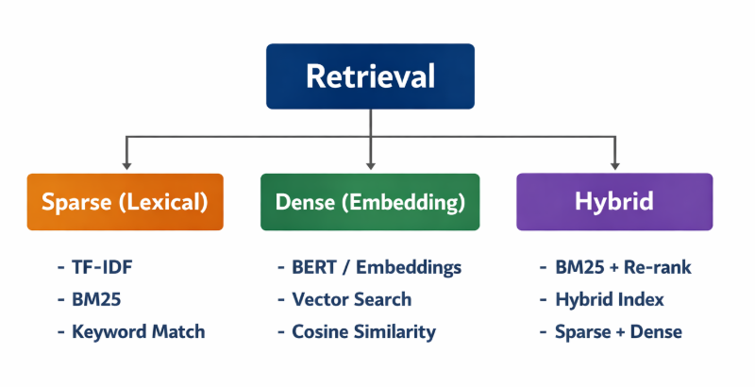
- Sparse (Lexical): Keyword-based search (e.g., TF-IDF, BM25) using exact term matching.
- Dense (Embedding): Semantic search using vector embeddings and similarity metrics.
- Hybrid: Combines lexical and semantic methods for balanced precision and recall.
For semantic chunking and semantic retrieval, we use embeddings and when we use embeddings, we need to use vector indexing when we want a faster and optimized response when the dataset is large.. Below are the techniques.

Vector Indexing Techniques
When using embeddings, the key challenge is fast nearest-neighbor search. Exact search (brute force) is too slow at scale, so specialized indexes are used. Popular ANN (Approximate Nearest Neighbors) methods include:
- Flat (Brute-Force): Store vectors in a list and compare a query to every vector. This yields 100% recall (perfect accuracy) but is slow. Flat indexes have no approximation, so search time grows linearly with the data. They are only practical for small collections or where query time is not critical[12].
- Locality-Sensitive Hashing (LSH): Maps vectors into hash buckets so that similar vectors collide. LSH can be very fast for low-dimensional data, but suffers in high dimensions (needs many bits to maintain accuracy). In practice, LSH works only on low-dimensional or small datasets, and recall drops if the dimensionality or index size grows[13][14].
- Hierarchical Navigable Small Worlds (HNSW): Builds a multi-layer proximity graph. Searches traverse from long-range links (top layer) down through shorter links, “zooming in” to the nearest neighbors[15][16]. HNSWlib (and similar implementations) are extremely popular: they offer top-tier accuracy (recall up to ~0.9–0.95) with very fast query speed[15][17]. The tradeoff is memory: HNSW graphs can be large in RAM. HNSW excels on large, high-dimensional datasets when loaded in memory, and is known for good speed on CPU (even without GPU)[17][18].
- Inverted File (IVF) + Product Quantization (PQ): IVF first clusters the data into cells (Voronoi regions), then searches only a few cells. This greatly speeds search for large datasets[19]. Adding PQ compresses vectors in each cell by quantizing them, further saving memory[20][21]. IVF+PQ (e.g. Faiss’s IndexIVFPQ) is a common choice for very large collections (millions+ vectors). It gives a good balance of speed, memory, and accuracy (with tuning of parameters like number of cells nlist and probes nprobe)[19][21]. For example, increasing nprobe searches more clusters for higher recall, while more PQ bits reduce memory at some loss in accuracy.
A summary comparison of index types (on 1M vectors, 128-dim) shows the tradeoffs[14]:
- Flat: perfect recall (1.0) but slow.
- LSH: very low memory and fast but low recall on high-dim data (recall ~0.4–0.85).
- HNSW: high recall (up to ~0.95) and fast, but high memory (hundreds of MB).
- IVF: good recall (~0.7–0.95), moderate speed and memory.
(Source: Pinecone/FAISS experiments[14].) In practice, one chooses based on data size and requirements: small data or exact results → Flat; very large data with limited RAM → IVF/PQ or HNSW; specialized use (low-dim or streaming) → LSH or other.

Embedding Generation Options
Embeddings are generated by neural models that convert text (or other data) into vectors. Key options:
- Transformer-based Sentence Embeddings (e.g. SBERT): These produce high-quality semantic vectors. Models like Sentence-BERT (built on BERT/RoBERTa/MPNet) generate contextual sentence embeddings tuned for similarity[22]. They are open-source and can be run locally (no API fees)[22]. However, they require substantial compute (GPU advisable for large corpora) and the quality depends on the model and fine-tuning[23]. Many pre-trained SBERT models exist for different languages and domains.
- OpenAI (and Cohere) Embeddings: API-based embedding models (e.g. OpenAI’s text-embedding-ada-002 or Cohere’s embeddings) trained on massive data. They often yield very strong semantic accuracy[24]. Advantages include ease of use and high quality for general text. Downsides are latency, cost per call, and less privacy/control. These are ideal for production semantic search if cost and API use are acceptable[24].
- Static Embeddings (Word2Vec, GloVe, FastText): Classic embeddings map words (or averaging to sentences) into vectors. They are static (each word has one vector) and much cheaper to compute. FastText, for example, handles out-of-vocabulary words via subword units[25]. These vectors are less precise on context and polysemy (a word’s meaning in context) but are lightweight and efficient[26][27]. They can serve as a fast baseline or for tasks with limited resources.
- LLM-derived Embeddings: Emerging techniques use large LLMs to generate embeddings (sometimes via hidden-state vectors or special prompts). These can capture very rich context but are usually accessed via API (e.g. embeddings from GPT-4o) or require running large models. Fine-tuning (e.g. SetFit) can specialize smaller transformer models on-domain, achieving high quality for a fraction of LLM cost[28]. Overall, choosing an embedding model involves a tradeoff between accuracy vs. cost/latency[24][28].
In summary, model choice depends on domain and constraints. For general-purpose semantic search, OpenAI/Cohere or a robust SBERT model is common[24][22]. For on-premise or cost-sensitive cases, an open-source SBERT or even FastText might suffice. For very domain-specific data, fine-tuning an SBERT/SetFit model often yields the best results[28].

Semantic Chunking Deep Research.
Since we are here to explore semantic chunking, there are 8 major ways for semantic chunking:
1. Embedding + Threshold Similarity (Greedy Merge) | 2. Embedding + Sliding Similarity Window
Description: Embed sentences and merge adjacent ones while similarity stays above a fixed threshold.  Advantage: Simple, fast, and widely used in production.  Disadvantage: Sensitive to threshold choice; may over-merge or over-split. | Description: Compare adjacent sentence embeddings and split at sharp similarity drops.  Advantage: Detects natural semantic boundary shifts.  Disadvantage: Struggles with gradual topic transitions.
3. Clustering-Based (Global Clustering) | 4. Graph-Based Community Detection
Description: Cluster sentence embeddings (e.g., KMeans, Agglomerative, DBSCAN) and group contiguous clusters.  Advantage: Captures global semantic structure across the document.  Disadvantage: Ignores document flow unless post-processing enforces order. | Description: Build a similarity graph of sentences and detect communities (e.g., Louvain, Infomap).  Advantage: Strong at identifying multi-topic structures in long documents.  Disadvantage: Computationally heavier and harder to tune.
5. Change-Point Detection on Embedding Distance | 6. Topic Distribution Shift
Description: Treat similarity scores as a time series and detect statistical change points.  Advantage: Principled signal-processing approach to boundary detection.  Disadvantage: May detect statistical shifts that lack semantic meaning. | Description: Compute topic distributions per sentence (e.g., LDA, neural topic models) and split on dominant topic shifts.  Advantage: Interpretable topic-level segmentation.  Disadvantage: Coarser semantic resolution than embeddings.
7. LLM-Guided Semantic Segmentation | 8. Hybrid Multi-Stage Semantic Chunking
Description: Prompt an LLM to split text into coherent, self-contained segments.  Advantage: Highest semantic awareness and contextual understanding.  Disadvantage: Expensive, slower, and less deterministic. | Description: Combine multiple approaches (e.g., TextTiling + embeddings, sliding window + LLM refinement).  Advantage: Production-grade robustness and accuracy.  Disadvantage: Higher system complexity and maintenance cost.
What are the other alternatives to Semantic Chunking:
Method | Idea | Good For | Weak For
Fixed Token | Fixed length split | Speed | Meaning loss
Sliding Window | Overlapping chunks | QA tasks | Redundant storage
Paragraph Based | Natural breaks | Structured docs | Poor for messy docs
Recursive Split | Split by headings → sentences | Well structured docs | Poor in unstructured
Semantic Chunking | Similarity threshold | Complex context | Slower
LLM Chunking | LLM detects topic shifts | High accuracy | Expensive
Metrics for Retrieval in the RAG pipeline:
Now let us focus on the similarity metrics to search in the retrieval segment of RAG pipeline.
When we use dense vector search, we have the following options to proceed for choosing the metrics:
Metric | Formula Intuition | What It Measures | Pros | Cons | When To Use
Cosine Similarity | Angle between vectors | Direction similarity (ignores magnitude) | Stable, scale invariant, most common | Slightly slower than dot product | Default choice for semantic search
Dot Product | Sum of element-wise multiplication | Direction + magnitude | Fast, works well with normalized embeddings | Sensitive to vector scale | When embeddings are normalized or trained with dot objective
Euclidean (L2) | Geometric distance | Absolute distance in space | Simple | Not scale invariant | Rare in modern semantic search
Manhattan (L1) | Sum of absolute differences | Coordinate-wise distance | Robust to outliers | Rarely used in embeddings | Specialized numeric embeddings

When we are not using vector embeddings and going ahead with the lexical search, here are the options:
Method | Type | What It Measures | Strength | Weakness | When To Use
BM25 | Sparse lexical | Keyword frequency + rarity | Strong exact match | Fails on synonyms | E-commerce, logs, legal keywords
TF-IDF | Sparse lexical | Term importance | Lightweight | Weak semantic power | Small corporate
Hybrid (BM25 + Dense) | Combined | Keyword + semantic | Best of both | More complex | Production systems

Now for semantic chunking we will experiment 4 different methods and try to find out which excels:
- Fixed tokens chunking:
Key Components for Fixed Token Chunking
- Method: Fixed-Size Tokenization. This approach uses a tokenizer (like tiktoken) to convert strings into integers (tokens) and groups them into chunks of an exact length. This is crucial because LLMs have strict limits on the number of tokens they can process at once.
- Similarity Matrix: Cosine Similarity. When the vector database (ChromaDB) indexes the embeddings, it calculates the "closeness" of vectors using the cosine of the angle between them. This is the standard metric for determining how relevant a document chunk is to a user's search query.
- Database: ChromaDB. An open-source, AI-native vector database used to store the embeddings and their corresponding text metadata for fast retrieval.

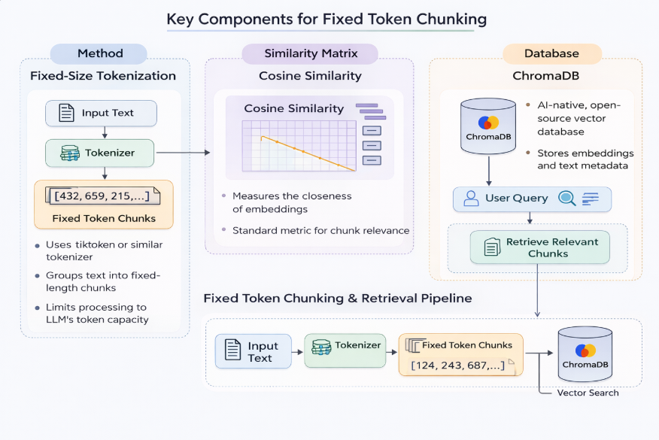

- Sliding window chunking method:
Key Components for Sliding Window
- Method: Sliding Window Tokenization. This uses a "stride" or "offset" approach. If the window size is 200 and the overlap is 50, the first chunk covers tokens 0–200, and the second covers 150–350.
- Similarity Matrix: Cosine Similarity. Since the windows contain redundant data, the similarity matrix in the vector database will often show high correlation between adjacent chunks. This helps the RAG system retrieve multiple relevant surrounding windows to provide a fuller context to the LLM.
- Database: ChromaDB. The database handles the increased storage volume (due to overlapping data) and allows for fast nearest-neighbor retrieval.

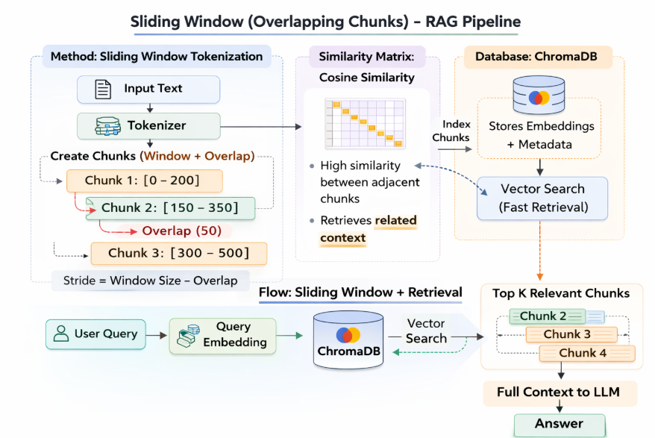
- Recursive split method:
Key Components for Recursive Splitting
- The Method: Hierarchical Character Splitting. This method uses a prioritized list of separators: ["\n\n", "\n", " ", ""]. It attempts to split at the first separator (double newlines); if the resulting chunk is still larger than the chunk_size_int, it recursively moves to the next separator in the list until the size constraint is met.
- Similarity Matrix: Cosine Similarity. Since this method keeps paragraphs and sentences whole, the resulting embeddings are semantically "cleaner" (less noise from cut-off sentences), leading to highly accurate cosine similarity scores during retrieval.
- Database: ChromaDB. This vector store indexes the variable-length (but capped) chunks and maps them to their high-dimensional embedding vectors.

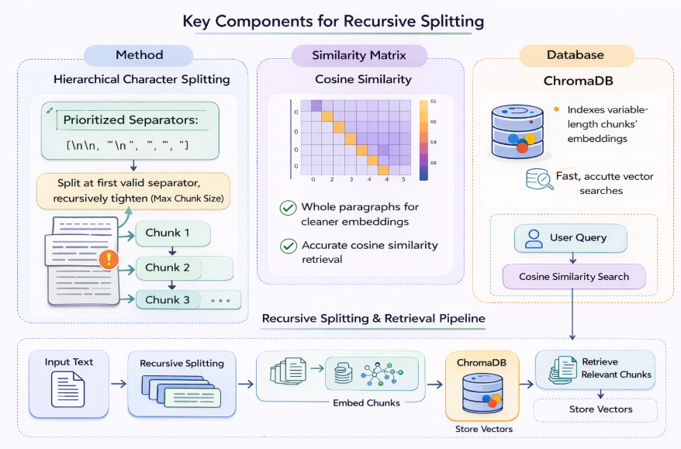

- Semantic Chunking:
Flowchart Breakdown and Key Components
This section details the specific components utilized in the codebase.
1. The Method: Semantic Chunking via Recursive Embedding
The core logic implemented is Semantic Chunking. Unlike fixed character or token methods, this technique recursively analyzes the semantic content of the text to find natural breakpoints.
- Logic: It identifies shifts in meaning by analyzing the similarity between consecutive sentences. When a new sentence differs significantly from the preceding context (defined by a statistical threshold), it is treated as a topic shift, and a new chunk is generated. This ensures that paragraphs or narrative thoughts remain cohesive.
2. Similarity and Distance Metrics
The algorithm relies heavily on embedding vectors to represent the "meaning" of text. The following metrics are used to compare these vectors:
- Embedding Model: The sentence-transformers/all-MiniLM-L6-v2 model transforms both sentences and final chunks into dense, 384-dimensional vectors.
- Similarity Measure: During retrieval, Cosine Similarity is used to determine how closely the user's query vector matches the vectors stored in the database.
- Distance Measure (Chunking): During the chunking phase, the inverse metric, Cosine Distance (where Distance = 1 - Similarity), is calculated between consecutive sentence embeddings to identify significant semantic gaps.
3. Database: ChromaDB
We utilize ChromaDB as the underlying storage and retrieval engine.
- Type: A dedicated vector database (or semantic vector store).
- Function: ChromaDB indexes the embedded text chunks generated by the semantic chunker. During retrieval, it executes efficient nearest-neighbor searches (vector searches) to quickly find and return the top K most relevant chunks that align with the semantic vector of the user's query.

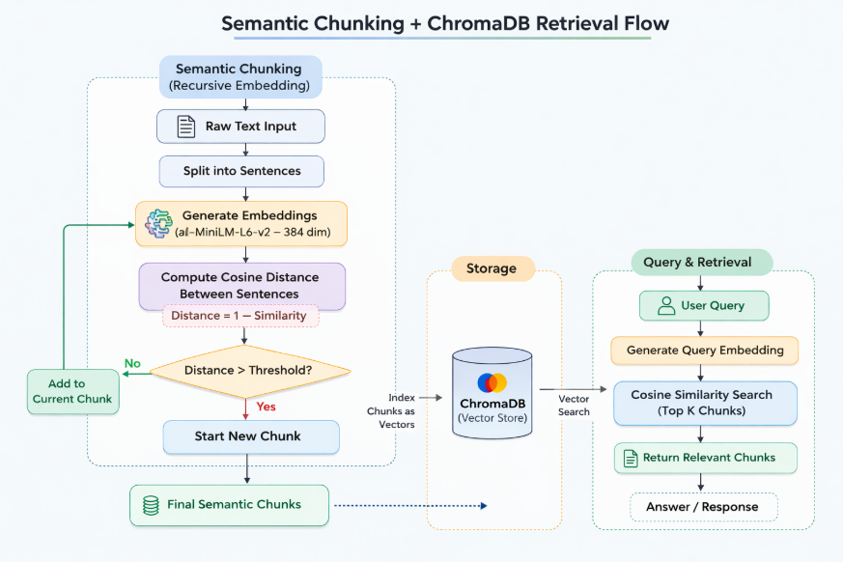

10 Scenarios for which we can see different approaches are:
Scenario | Primary Problem | Ideal Approach
1. Academic Research | Conceptual queries, long texts | Semantic Chunking + Cosine + HNSW
2. Legal Clauses | Exact wording needed, but with synonyms | Hybrid Search (BM25 + Dense Vectors)
3. E-commerce | Exact numeric constraints (prices, sizes) | Hybrid Search + Metadata Filtering
4. FAQ Chatbot | Small dataset, short Q&A formats | Fixed Chunking + Cosine Similarity
5. Medical Papers | Deep context needed for technical jargon | Semantic Chunking (Tuned) + Cosine
6. Log/Error Search | Need exact codes and strings; meaning is noise | BM25 (Pure Lexical Keyword Search)
7. Edge Devices | Low RAM, needs high efficiency | PQ Compression + HNSW + Dot Product
8. Multilingual | Queries and docs in varying languages | Multilingual Embeddings + Cosine
9. Code Search | Structural code matching, function value | Dot Product
10. Enterprise RAG | High recall + High precision at scale | Hybrid Search + HNSW + Reranking
Detailed explanation: 10 scenarios for RAG

Comparison table for semantic and lexical similarity:
Feature | Semantic Similarity | BM25 (Lexical) | Hybrid
Captures meaning | Yes | No | Yes
Handles synonyms | Yes | No | Yes
Exact keyword match | Weak | Strong | Yes
Numeric search | Weak | Moderate | Yes
Speed | Medium | Fast | Medium
Memory usage | High | Low | Medium
Explainability | Low | High | Medium
Good for paraphrasing | Yes | No | Yes
Large-scale ready | Yes | Yes | Yes
Best overall quality | ⭐⭐⭐⭐ | ⭐⭐⭐ | ⭐⭐⭐⭐⭐

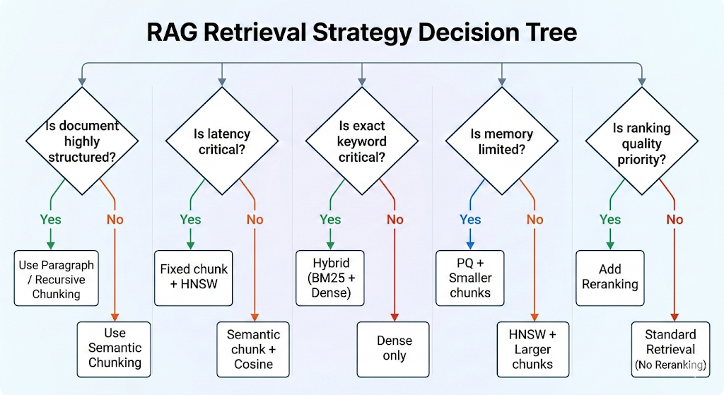

Scenario-Based Method Selection
Here are general ten illustrative scenarios with recommended methods:
- General Knowledge QA (complex concepts, synonyms important): Use dense embeddings for retrieval. For example, average SBERT vectors or OpenAI embeddings, with a high-recall index (HNSW or IVF+PQ)[4][14]. This captures semantics beyond exact keywords.
- Legal/Regulatory Search (exact phrases matter): Use sparse keyword search (BM25 on full-text) because precise terms are critical[5]. Combining with a smaller semantic reranker (to filter) can help, but primary retrieval should be lexical.
- Domain-Specific Text (e.g. medical records): Fine-tune or use a specialized embedding model (SBERT trained on medical text) for semantic search[28]. Domain vocabulary may differ, so an in-domain model will outperform a generic one.
- Large-Scale Image+Text Database: If queries involve images/text similarity, use multimodal embeddings (e.g. CLIP) and vector search. Index with HNSW (GPU-accelerated if available) to handle millions of high-dim vectors with low latency[21].
- Real-Time Search (low latency): Use a fast ANN index like HNSW (with moderate ef settings) on a GPU or high-spec CPU[15][21]. Keep embeddings moderate-sized and pre-compute offline. Consider pre-filtering with keywords if applicable.
- Memory-Constrained Deployment: Use compressed indexes like IVF+PQ to reduce storage[21]. A smaller SBERT model or static embeddings (FastText) may be needed. Increase IVF cell count with PQ to trade recall for memory.
- Privacy-Sensitive or Offline: Use on-device or locally hosted embeddings (e.g. a small SBERT) and local index (FAISS or Annoy). Avoid API-based embeddings like OpenAI due to external calls.
- Multi-Language Search: Choose multilingual embeddings (mUSE, multilingual BERT) so that semantic search works across languages. Alternatively maintain separate sparse indexes per language and use translation.
- Hybrid Use Case (precise + semantic): If some queries need exact match and others semantic, use a hybrid approach. For instance, run BM25 to get candidates and then re-rank with dense similarity[9]. Or build a hybrid index (Oracle style) that combines tokens and vectors[11].
- Low-Resource Model / Cost-Saving: If compute budget is limited, use a smaller embedding model (DistilBERT-based SBERT) and an efficient index (Annoy or small HNSW)[23][28]. Flat search on a small SBERT index might suffice for short docs.
For each scenario, the choice hinges on data size, query type, hardware, and acceptable tradeoffs between precision, recall, latency, and cost[5][14].

Comparison Summary
In summary, semantic search (embedding + vector similarity) offers rich understanding of query intent and is best for nuanced, context-driven queries[6], while cosine similarity is simply the distance metric often used to score semantic matches[7][8]. Traditional cosine-based TF-IDF search (as in Lucene/Elasticsearch) is fast but literal, whereas embedding-based cosine search finds conceptual matches. Metric choice (cosine vs dot vs L2) can be tuned, but cosine is popular for its focus on direction (semantic similarity)[7]. Advanced retrieval systems often mix methods (vector + lexical + re-ranking) to leverage their complementary strengths[9][10].

Sources: We draw on industry and academic benchmarks of retrieval methods[4][14] and chunking strategies[1][29], alongside vendor guides (Oracle, Pinecone) and community research, to inform these recommendations. Each method above has documented trade-offs in practice[5][14].
References:
[1] Semantic Chunking for RAG. What is Chunking ? | by Plaban Nayak | The AI Forum | Medium
https://medium.com/the-ai-forum/semantic-chunking-for-rag-f4733025d5f5
[2] Semantic Chunking: Improving AI Information Retrieval | by Nirdiamant | Medium
https://medium.com/@nirdiamant21/semantic-chunking-improving-ai-information-retrieval-2f468be2d707
[3] docs.oracle.com
https://docs.oracle.com/en/database/oracle/oracle-database/26/vecse/img_text/23_7_ai_vector_workflow.html
[4] [5] [6] [10] What is the difference between sparse and dense retrieval?
https://milvus.io/ai-quick-reference/what-is-the-difference-between-sparse-and-dense-retrieval
[7] [8] [9] Vector search vs semantic search: 4 key differences and how to choose
https://www.instaclustr.com/education/vector-database/vector-search-vs-semantic-search-4-key-differences-and-how-to-choose/
[11] Oracle AI Vector Search Workflow
https://docs.oracle.com/en/database/oracle/oracle-database/26/vecse/oracle-ai-vector-search-workflow.html
[12] [13] [14] [15] [19] Nearest Neighbor Indexes for Similarity Search | Pinecone
https://www.pinecone.io/learn/series/faiss/vector-indexes/
[16] Hierarchical Navigable Small Worlds (HNSW) | Pinecone
https://www.pinecone.io/learn/series/faiss/hnsw/
[17] [18] [21] Faiss vs HNSWlib on Vector Search - Zilliz blog
https://zilliz.com/blog/faiss-vs-hnswlib-choosing-the-right-tool-for-vector-search
[20] Vector Database Comparison for AI Developers | Medium
https://felix-pappe.medium.com/vector-database-comparison-for-ai-developers-90aeb3d79caf
[22] [23] [24] [25] [26] [27] Comparing Popular Embedding Models: Choosing the Right One for Your Use Case - DEV Community
https://dev.to/simplr_sh/comparing-popular-embedding-models-choosing-the-right-one-for-your-use-case-43p1
[28] Comparing LLMs and Sentence Transformers for Domain-Specific Classification | by Ilias Paschalis | Medium
https://medium.com/@i.paschalis/comparing-llms-and-sentence-transformers-for-domain-specific-classification-1a9f883baeeb
[29] Evaluating Chunking Strategies for Retrieval | Chroma Research
https://research.trychroma.com/evaluating-chunking

